**JUNAID KHAN – SP20-BSE-066**

**RAILWAY RESERVATION SYSTEM**

**CANCEL TICKET (USE CASE)**

**BRIEF**

This Use Case starts when the passenger wants to cancel the ticket. Passenger will click the ticket details and check to whether cancel the ticket or not. If the passenger wants to cancel the ticket, he/she will click the cancel the button Infront of his/her ticket details. The ticket will proceed to be cancelled and ticket price will be refunded with deduction according to the time.

The ticket of the passenger will be cancelled.

**FULLY DRESSED**

|  |  |
| --- | --- |
| Use Case ID: | 1 |
| Use Case Name: | Cancel Ticket |
| Actors: | Passenger |
| Description: | This prompts you to the home page of the application if the email and password asked are valid |
| Trigger: | This is a Button On-Click event |
| Pre-Conditions: | The user should have account on Train’s portal |
| Post-Conditions: | User is directed to home page of the application if the log in is successful |
| Normal Flow: | 1. User enters email 2. User is directed to the home page |
| Alternative Flows: | 2a. If the user has forgotten the password:   1. User is required to go through “Forget Password” procedure |
| Exceptions: | 1a. If the email provided by the user is in incorrect format:   1. User is asked to re-enter his email/password   1b. If the email/password section is left empty:   1. The user is asked to enter his email/password |
| Includes: | Authentication |
| Special/Quality Requirements (Other Information): | * Information is forward for authentication within 3 seconds |
| Assumptions: | The user has submitted his information to validate and sign in |

**Use Case Diagram**

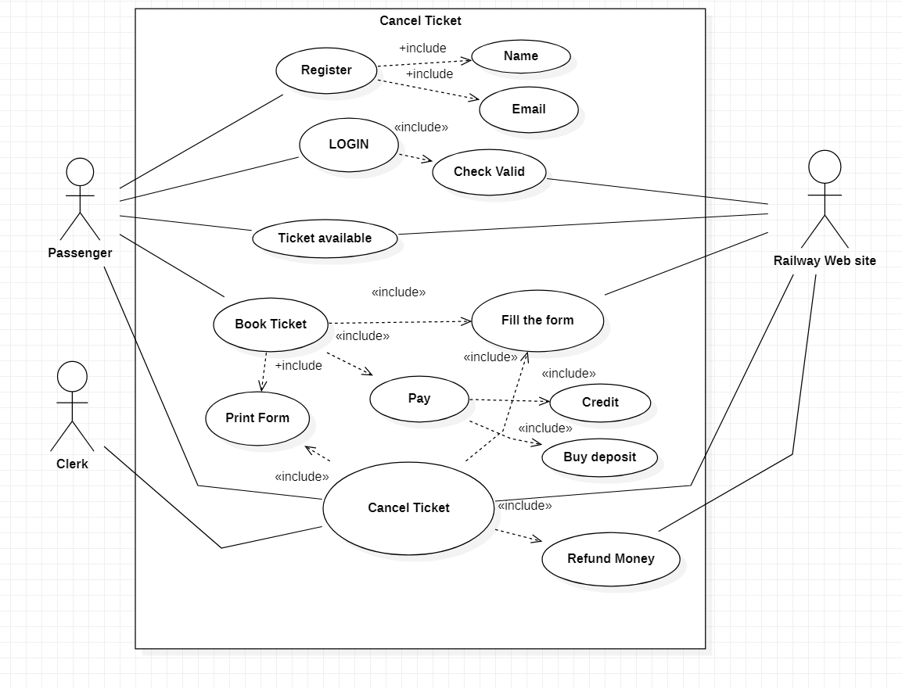

Domain Model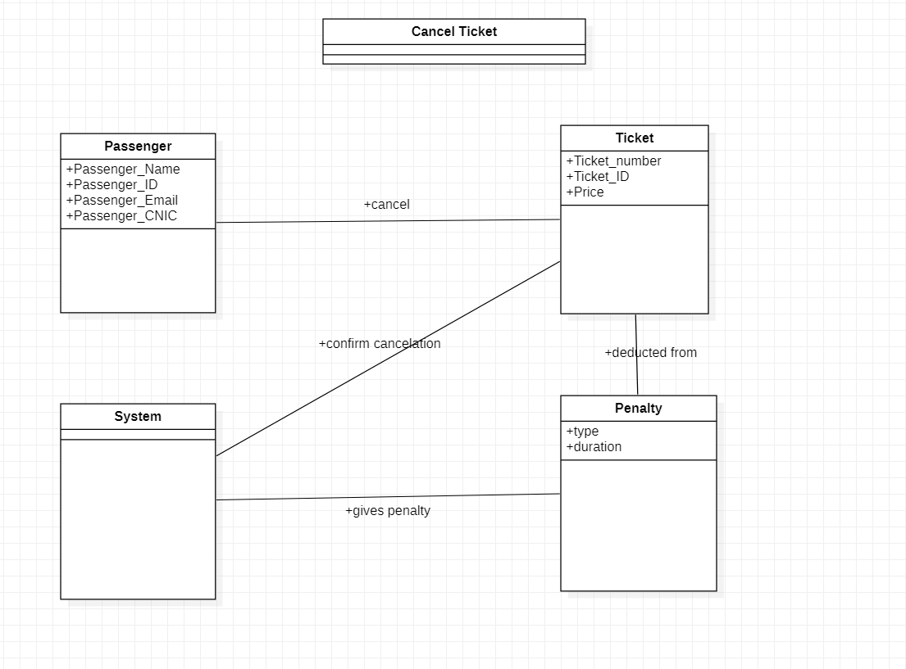

System Sequence Diagram

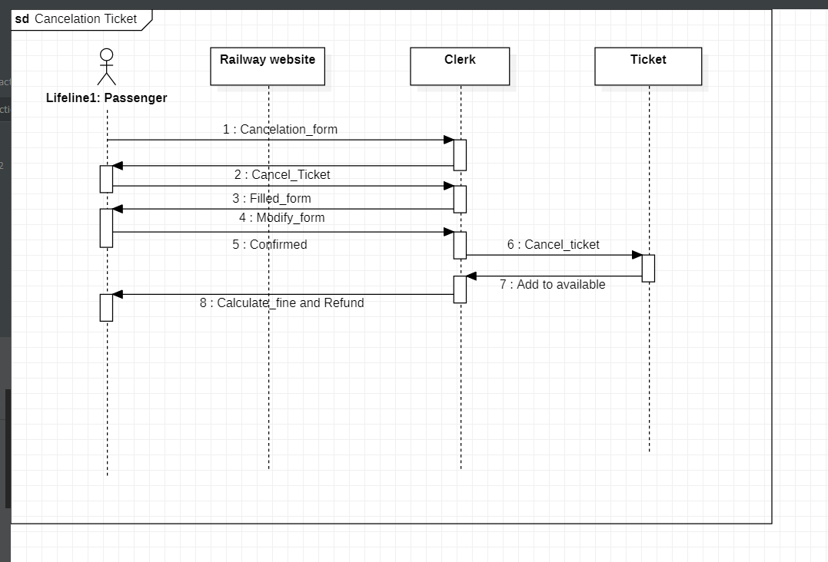

Operation Contracts

**OPERATION –** Click Cancel

**CROSS REFERENCE –** Cancel ticket

**PRECONDITION –** the passenger must be registered and logged in and must have booked a ticket

**POSTCONDITION –** the ticket will proceed to be cancelled